**DATA GATEWAYS** & **DATA REFRESH**

**POWER BI GATEWAYS** [ALSO CALLED AS "DATA GATEWAYS"] : AN APPLICATION THAT NEEDS TO BE INSTALLED IN THE COMPUTER WHERE THE ACTUAL DATA SOURCE RESIDES / ACCESSIBLE.

USED FOR SCHEDULED, INCREMENTAL DATA REFRESH BETWEEN DATA SOURCE TO POWER BI CLOUD.

INSTALLATION REQUIREMENTS: 64 BIT WINDOWS OS, ANY PROCESSOR.

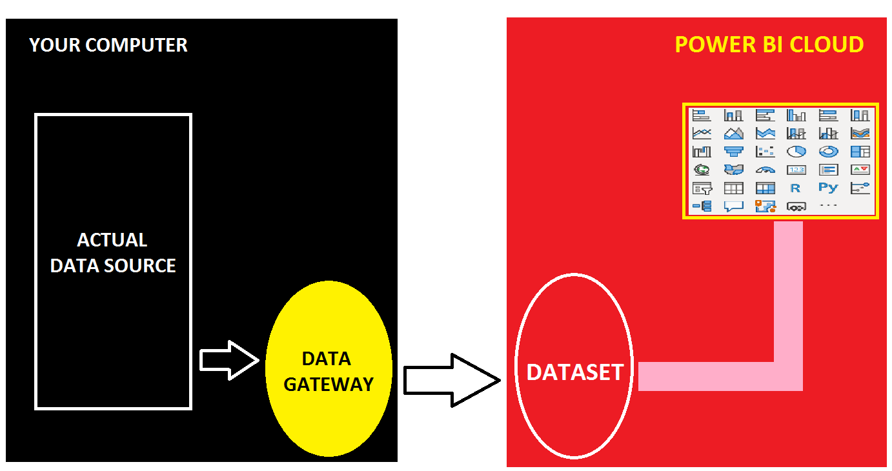

**STEP 1:** IDENTIFY THE SOURCE OF POWER BI REPORT IN YOUR COMPUTER (EX: AN EXCEL FILE).

DESIGN REPORT IN POWER BI DESKTOP > PUBLISH TO CLOUD.

**STEP 2:** DOWNLOAD DATA GATEWAY FROM : <https://powerbi.microsoft.com/en-us/gateway/>

INSTALL THE GATEWAY > SELECT "**STANDARD MODE**" GATEWAY [MULTI USER CONNECTIONS].

WHEN PROMPTED, **SIGN IN** TO POWER BI CLOUD.

WHEN PROMPTED, **REGISTER** THE GATEWAY ON YOUR COMPUTER > SPECIFY **GATEWAY NAME** & PASSWORD > CONFIGURE. GATEWAY RUNS WITH "**NT SERVICE\PBIEgwService**" > CLOSE.

**STEP 3**: FROM POWER BI CLOUD > GO TO DATASET > SETTINGS > IDENTIFY ABOVE INSTALLED GATEWAY > CLICK @ ARROW MARK (>) AND CLICK @ ADD TO GATEWAY.

SPECIFY A DATA SOURCE NAME > SPECIFY YOUR COMPUTER CREDENTIALS > ADD.

GO TO DATASET > SETTINGS > IDENTIFY ABOVE INSTALLED GATEWAY > CLICK @ ARROW MARK (>) AND CLICK @ MAP TO DATA SOURCE > APPLY.

VERIFY DEFAULT PARAMETER VALUES.

SPECIFY SCHEDULES > APPLY.

**STEP 4:** PERFORM FEW MODIFICATIONS TO THE DATA SOURCE.

GO TO POWER BI CLOUD > DATASET > REFRESH. VERIFY UPDATED DATA IN REPORT.